Chapter 6, Solution 36.

Design a problem to help other students to better understand how inductors work.

Although there are many ways to work this problem, this is an example based on the same kind of problem asked in the third edition.

Problem

The current through a 12-mH inductor is 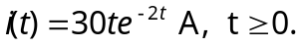 Determine: (a) the voltage across the inductor, (b) the power being delivered to the inductor at t = 1 s, (c) the energy stored in the inductor at t = 1 s.

Solution

(a) 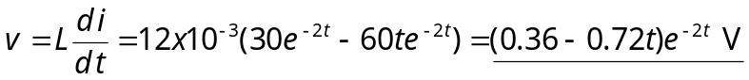
(b)
(c) 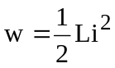 = 0.5x12x10^{–3}(30x1xe^{–2})² = 98.9 mJ.

